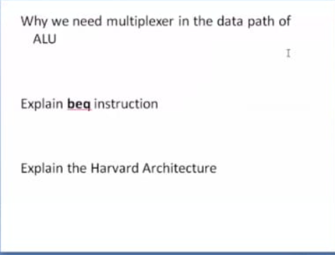

1. why we need a multiplexer in the datapath of ALU

* A multiplexer would select one of both inputs, in an ALU both inputs may be used simultaneously, depending on the pending operation.
* ALU stands for Arithmetic and Logic Unit, and those are the types of operations it performs

1. Beq :

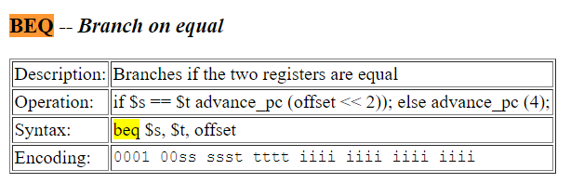

1. Harvard architecture :

* The Harvard architecture is a computer architecture with separate storage and signal pathways for instructions and data.
* Slower in speed, thus more time-consuming.
* Separate memories for code and data